From Source Text to Creative Production: Technological and Narrative Approaches to Shakespeare Adaptation for Expanded Animation (VR)
(Title: 16 pt, Microsoft YaHei, single spacing, bold, underline, left-alignment)
Hannes Rall¹, Emma Harper², Gelissa Loh³ and Jasper Teh³
(Author name: 10.5 pt, Times New Roman, 1.5 spacing)
¹Professor of Animation Studies and Associate Chair (Research), School of Art, Design and Media Nanyang Technological University, Singapore
²Research Associate, School of Art, Design and Media, Nanyang Technological University, Singapore
³Research Assistant, School of Art, Design and Media, Nanyang Technological University, Singapore
(Work place/institution of author: 9 pt, Times New Roman, italics)
Abstract: This paper focuses on an ongoing project to create an adaptation of the lesser-known Shakespeare play Pericles, Prince of Tyre for animated VR. In exploring this case study, we pay attention to both technical and narrative development outlining how our adaptation has been shaped by interdisciplinary scholarly knowledge, visual concerns, and technological possibilities. However, we argue that it is incorrect to assume that the lack of a fixed screen present in immersive media requires a focus solely on the technical and practical elements of animation production, instead demonstrating that expanded animation requires technological implementation that is fundamentally embedded in issues relating to narrative structure and the enduring unique vocabulary of animation as a medium.
(Abstract: 10.5-point font size, Times New Roman, 1.5 spacing)
Keywords: virtual reality, expanted animation, adaptation, Shakespeare
(Keywords: 10.5-point font size, Times New Roman, 1.5 spacing)
1. Introduction (Heading 1: 12pt, Times New Roman, double spacing, bold)
In their discussion of expanded and experimental animation, Smith and Hamlyn highlight a need to consider “how animation can be redefined when it is no longer articulated through the single screen alone,” and how such forms of animation involve a situation in which “traditional or commercial practices are exposed to new critical methodologies or re-workings” ¹. In this paper, we will provide insights into how expanded animation might manifest itself both theoretically and practically through the lens of our ongoing project to adapt Shakespeare’s Pericles, Prince of Tyre for gamified virtual reality (VR). This practice-led-research project is currently at the production stage and is particularly interested in exploring the implications of adapting works of Shakespeare for diverse
types of interactive digital media, and the relationship between narrative elements in the original text and the specific requirements of these media forms. In particular, the project seeks to interrogate how transforming a Shakespearean play into a serious game facilitates a non-linear and interactive approach to storytelling. Funded by the Singapore Ministry of Education (MoE) AcRF Tier 2 grant “From Print to Digital Continued,” the project is also keen to explore how taking an immersive approach to Shakespeare can impact upon students’ engagement with the original text and its meanings.
(Body: 10.5 pt, Times New Roman, 1.5 spacing, spacing between paragraphs: a line)
1.1 Environment (Heading 2: 10.5 pt, Times New Roman, 1.5 spacing, italics, bold)
1.1.1 Modelling and Rigging（Heading 3: 10.5 pt, Times New Roman, 1.5 spacing, italics)
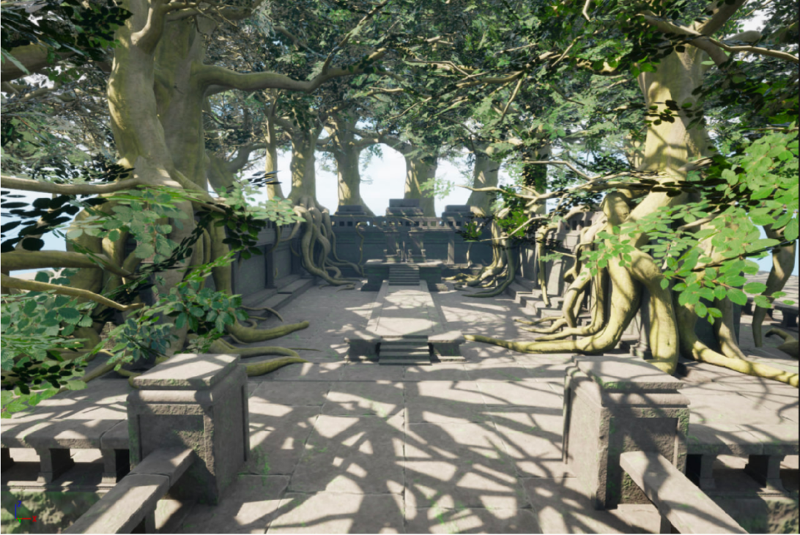
Fig 3. Screengrab from Unreal showing first pass of virtual environment.
(Illustration: 9 pt, Times New Roman, single spacing)

——————————————————————————————————————————————
This research is supported by the Ministry of Education, Singapore, under AcRF T2 Grant MOE-T2EP40120-003 “From Print to Digital Continued: Expanded Research into adapting Shakespeare for VR, AR and AI.” Any opinions, findings and conclusions or recommendations expressed in this material are those of the authors and do not reflect the views of the Ministry of Education, Singapore.
（Notes: 9 pt, Times New Roman, 1,15 spacing, positioned at the bottom of the page)
REFERENCES
[1] Vicky Smith and Nicky Hamlyn. “Introduction,” in Vicky Smith and Nicky Hamlyn (eds.). Experimental and Expanded Animation: New Perspecctives and Practices. Palgrave Macmillan Cham, 2018, p. 2. doi.org/10.1007/978-3-319-73873-4.
[2] Stephen Wittek and David McInnis. “Introduction,” in Stephen Wittek and David McInnis (eds.). Shakespeare and Virtual Reality. Cambridge Universit
(Reference: 9 pt, Times New Roman, 1.5 spacing)

